
MDF-User Manual
Marketing Development Funds Management
THERMALTAKE
2013/9/26

Copyright © 2013 Thermaltake Technology Co., Ltd. All Rights Reserved.

Index
1.System Introduction 2
1-1. Introduction 2
2. Account Registration 2
2-1. Apply for an account 2
3.Marketing Plan 4
3-1.Add, Edit And Delete 4
3-2.Apply 6
3-3.Completed 7
4. Statistics 8
4-1.Search by Status 8
4-2.Report 9
4-3.Bar Chart 9
5. Setup……… 9
5-1.Monthly Budget 10

- System Introduction
1-1.Introduction
【Description】
An Introduction for MDF
【Method & Steps】
MDF system offer sales to manage and record all marketing plans. Besides, statistics function can let manager analyse or make a decision.

System Workflow:
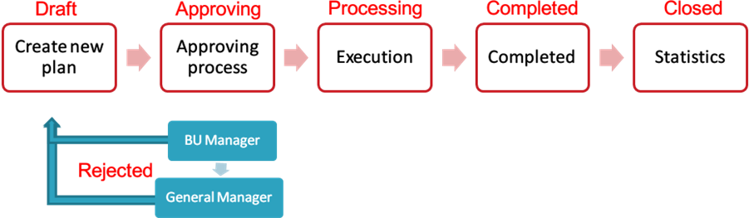

- Account Registration
2-1.Apply for an account
【Description】
Apply for a MRM&MDF account
【Method & Steps】
Step 1. Enter MDF System，click on Register
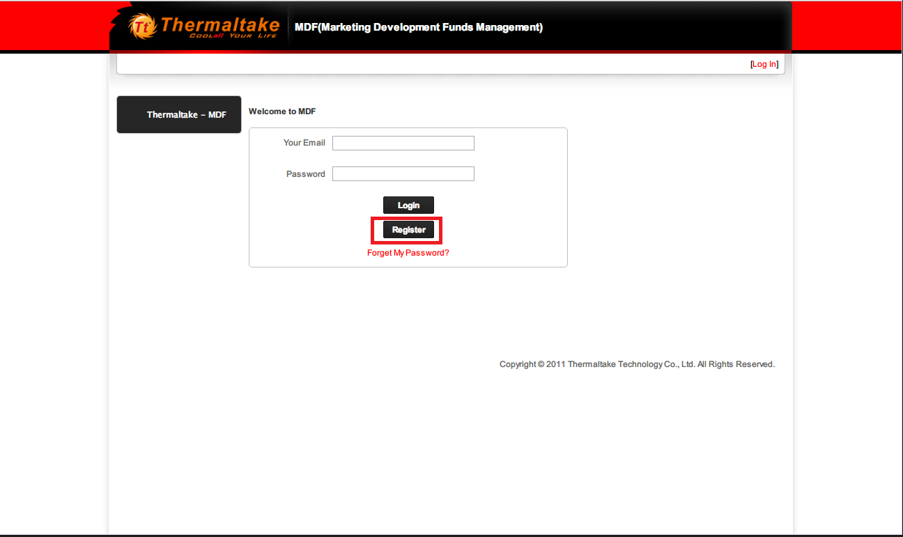

Step 2. Fill in all the necessary information，then click Apply
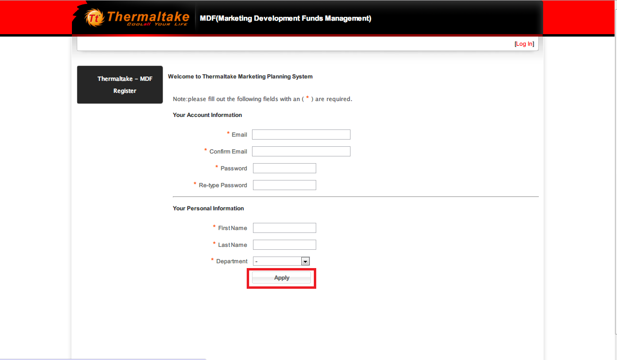

Step 3. Thermaltake employee need to logo on to WebEIP and fill out the “IT Trouble-shoot Form,” by stating “Apply for MRM&MDF account” on the topic blank section and the description of usage on the details blank section, once your account is approved by system administrator.

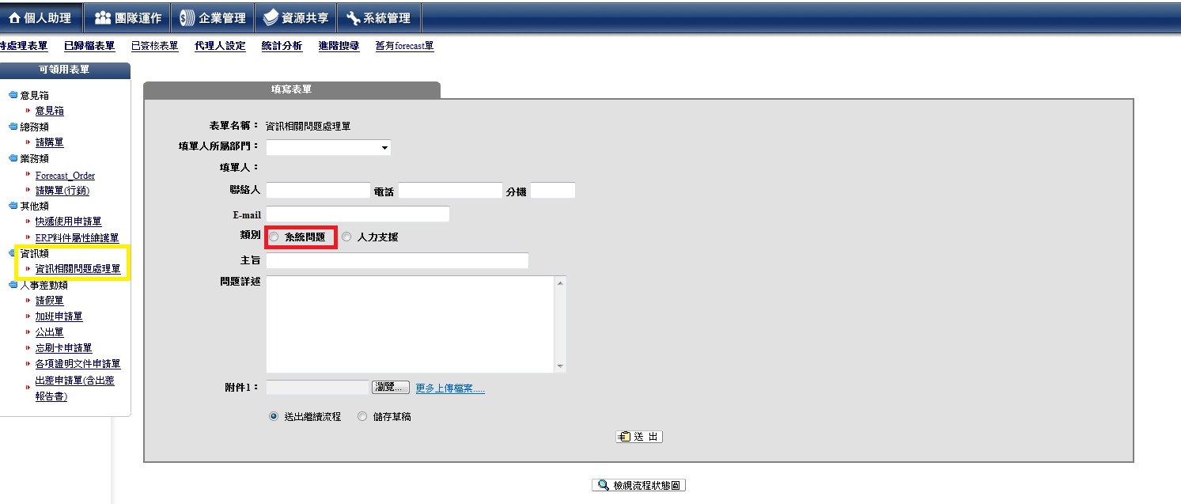
Note: For none Thermaltake employee, who would like to apply for a MRM&MDF account, please send the request to related contact Thermaltake employee.

- Marketing Plan
3-1. Add, Edit And Delete
【Description】
Create, modify and delete a marketing/promotion plan
【Method & Steps】
“Add”- Create a new marketing/promotion plan.
“Edit”- Modify the marketing/promotion plan.
“Delete” – Delete the marketing/promotion plan.
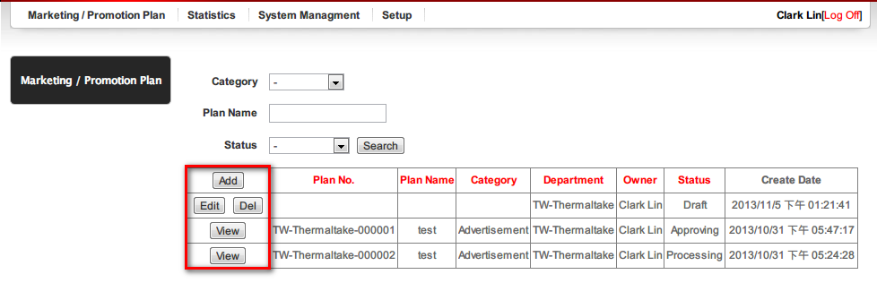

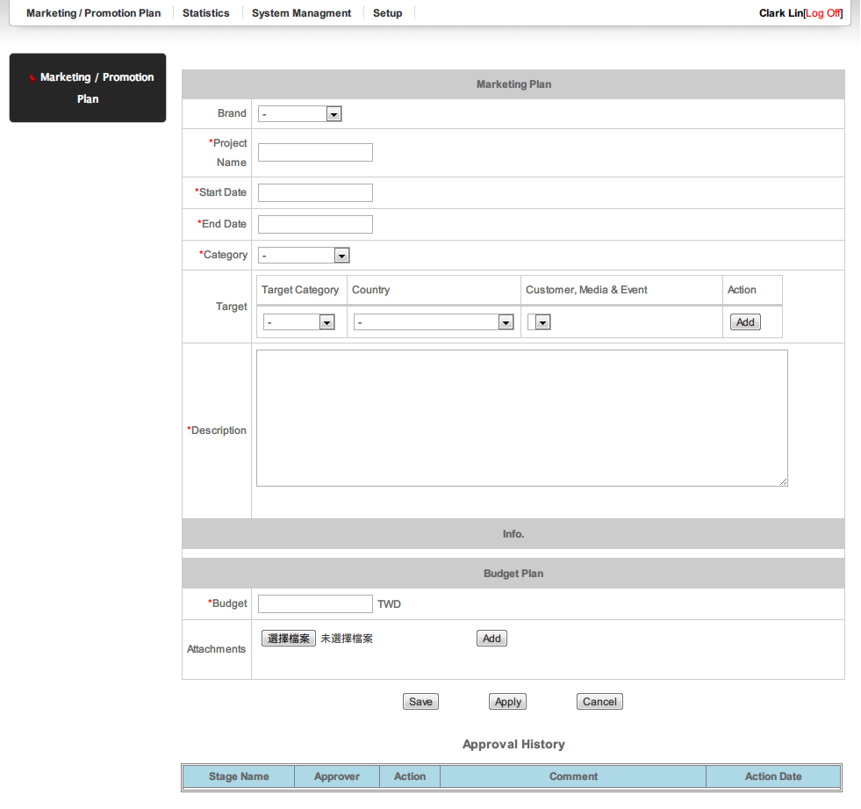

3-2 . Apply
【Description】
Apply a marketing/promotion plan
【Method & Steps】
When you fill out all required fields, you can press “Apply” button to apply the marketing plan.
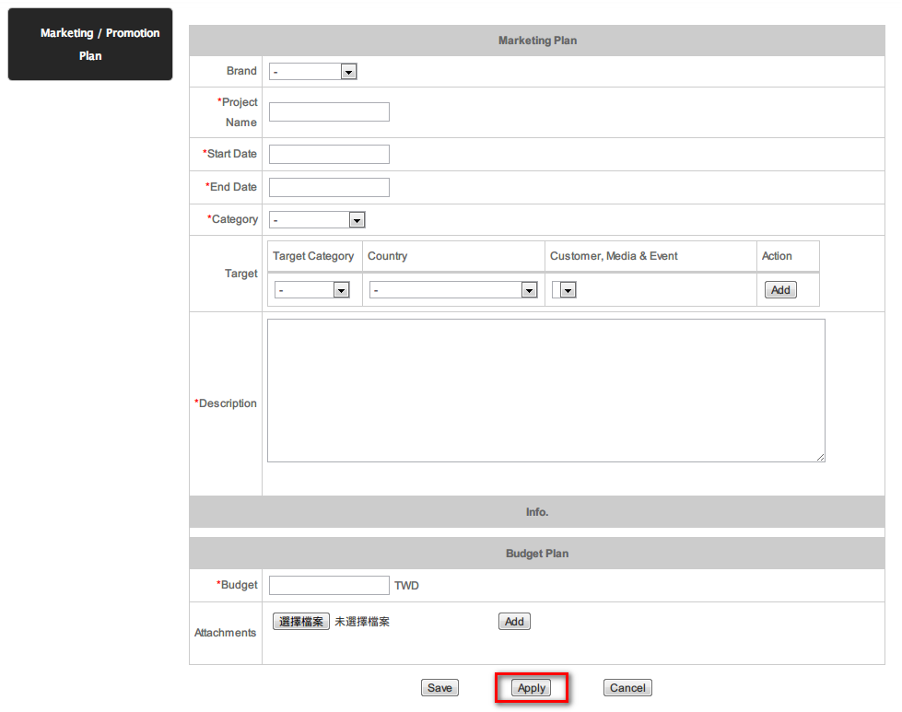
When the plan enter approval process, you can check the approval workflow at the bottom of the page.
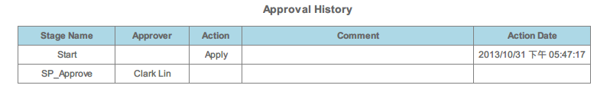
Note:If doesn’t approve yet, system will send notice to approver everyday.

3-3. Completed
【Description】
When the status of pan is completed, please update the actual expense.
【Method & Steps】
“Update” – Update the actual expense when the plan is completed.

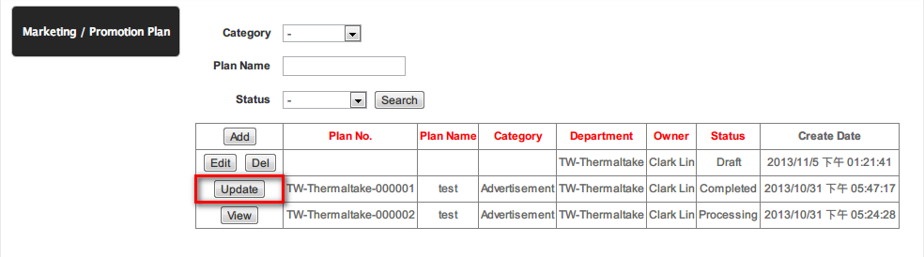
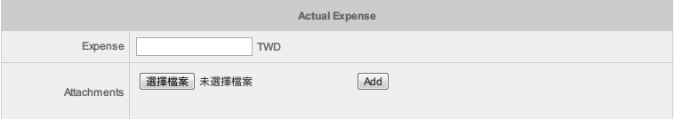
Note: If doesn’t update yet, system will send a notice to users per week.

- Statistics
4-1. Search by Status
【Description】
Search marketing plan by status and department
【Method & Steps】
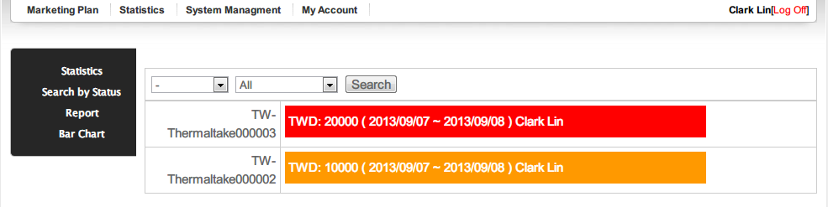
After press the link, you can see the content of plan.
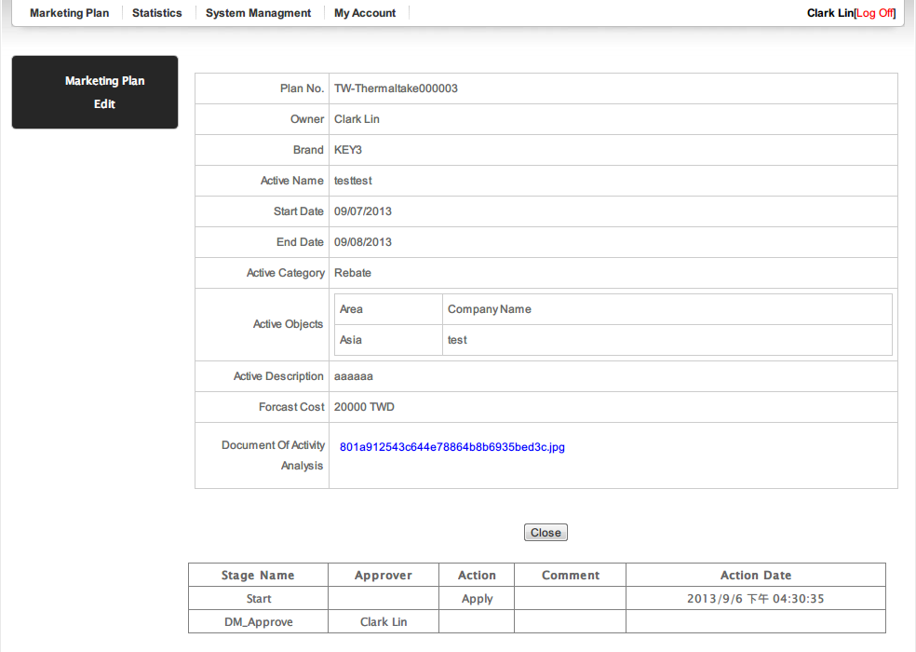
4-2. Report
【Description】
Generate report by status, country, brand, category and period
【Method & Steps】

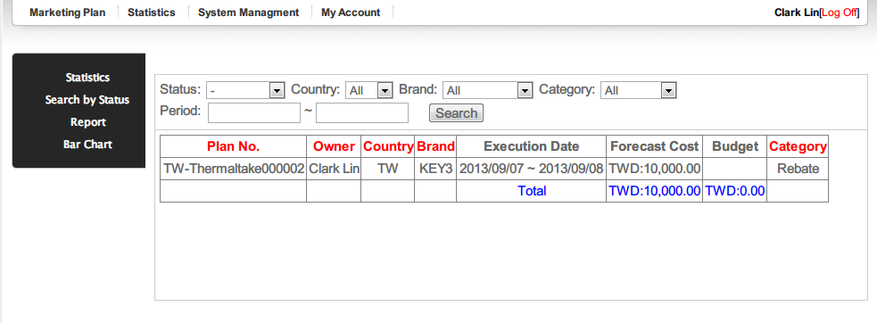
4-2. Bar Chart
【Description】
Generate Bar Chart by country, brand, category, status and period
【Method & Steps】
The Bar chart can compare budget and expense according to search condition.
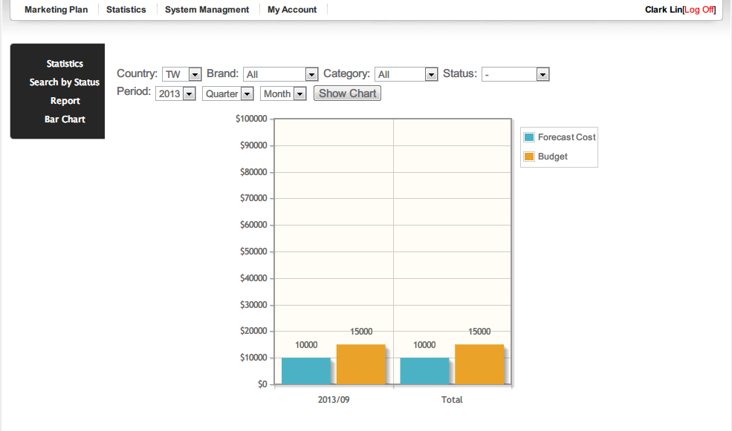
- Setup
4-1. Monthly Budget
【Description】
Maintain the personal monthly budget , These data will be displayed in the application form.
【Method & Steps】
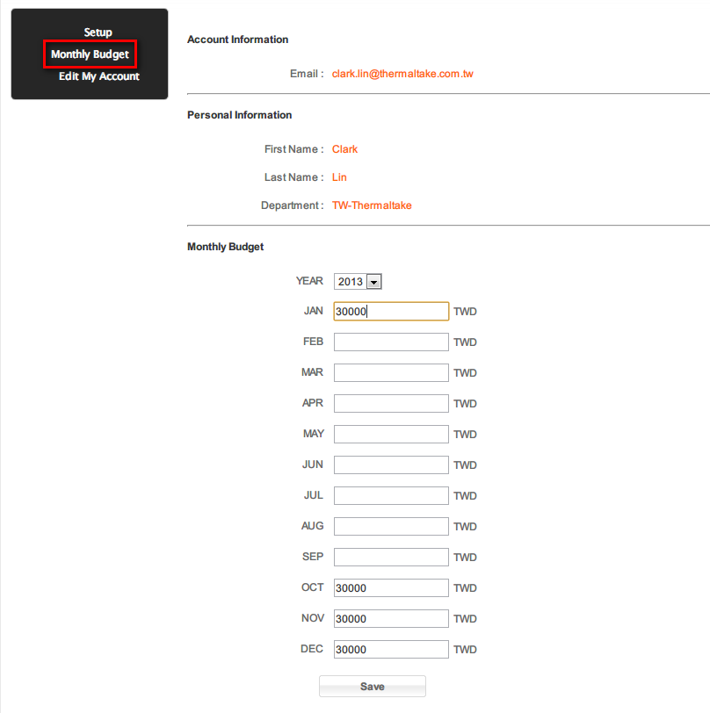

When fill out the Start date, the system will display the information.
